KURDISTAN TECHNICAL INSTITUTE
EduTech Academic Management System

Sending Letters to Departments
Staff Procedure Guide: Creating and Sending Internal Letters with the Divan
Document Details
Document type | Standard Operating Procedure (SOP)
System | EduTech – Documents Management System › Divan
Intended audience | All administrative and academic staff who send official letters
Number of steps | 8 steps

Contents
No. | Section | Covers
1 | Introduction | Purpose, scope and how to read this guide
2 | Process Overview | The system path and what to check before you begin
3 | Step-by-Step Procedure | Steps 1–8: opening your department's mail list and sending a letter
4 | Quick Reference Checklist | One-page summary of all eight steps
5 | Common Issues and Solutions | Troubleshooting frequent problems

1. Introduction

1.1 Purpose
This guide explains how to create and send an official letter from your department to another department or directorate using the Divan in the EduTech system. Every letter sent this way is numbered, archived in your department's mail list and delivered to the selected recipients.

1.2 Scope
The procedure applies to all departments sending internal letters. The example uses the IT department (ICT_Adm).

1.3 How to Read This Guide
- Bold text indicates a menu item, button or field name exactly as it appears in the system.
- Highlighted boxes on the screenshots show exactly where to click.
- Orange notes highlight important warnings; blue notes give helpful tips.

2. Process Overview
Steps | Purpose | System path
1–3 | Open your department's mail list. | Documents Management System › Divan › Sub Divan › Department Mail List
4 | Start a new letter. | Department Mail List › +
5–8 | Fill in the letter, choose recipients, attach files and send. | New letter form › Add

2.1 Before You Begin
- You are logged in with an account that has access to the Divan for your department.
- You know which department or directorate (or which employee) should receive the letter.
- Any files you want to attach are ready, for example a scanned signed letter.
Important: Choose the recipients carefully. If you select an employee's name, only that employee will receive the letter, not the whole department.

3. Step-by-Step Procedure
1 | STEP 1 Open the Divan  Screenshot markers: highlighted item

In the side menu, click Documents Management System, then click Divan.
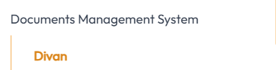
Figure 1: Side menu – Documents Management System › Divan
2 | STEP 2 Open Department Mail List  Screenshot markers: red box

To send a letter to another department, click Department Mail List under Sub Divan.
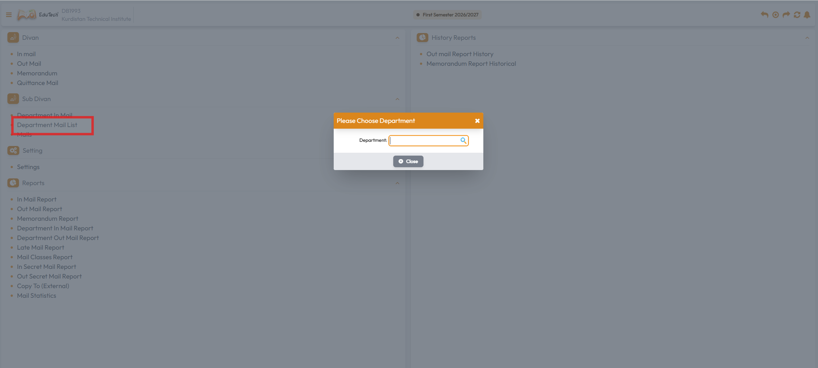
Figure 2: Divan page – Sub Divan › Department Mail List
3 | STEP 3 Choose your department

The Please Choose Department window opens (see Figure 2). Click in the Department field and press the Space key on your keyboard to show the list, then select your own department.

4 | STEP 4 Review your letters and start a new one  Screenshot markers: circled icon

The Department Mail List opens, showing all the letters your department has created, with the mail class, mail number, date, subject and recipient (Transformation target). The icons at the end of each row let you view, edit, print or delete a letter.
Click the + icon at the bottom-left of the table (circled) to create a new letter.
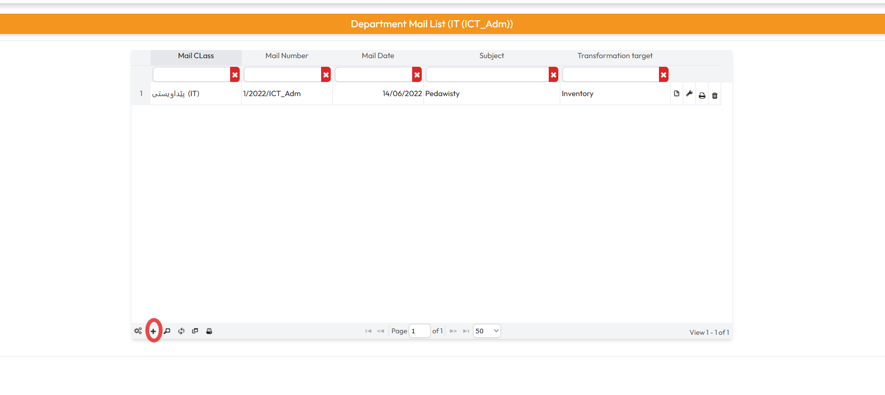
Figure 3: Department Mail List – creating a new letter with the + icon

5 | STEP 5 Enter the letter details  Screenshot markers: top of the form

The new letter form opens. Fields marked with a red star (★) are required. The full form is shown below; the next steps explain each part.
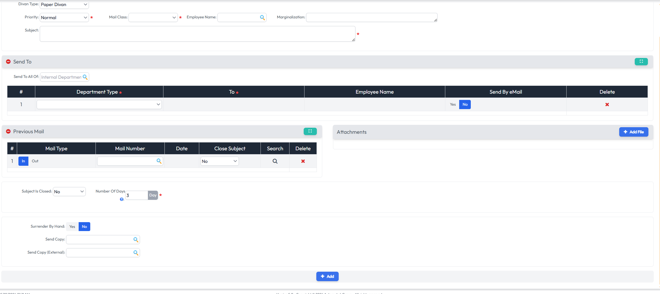
Figure 4: New letter form (full view)
Figure 5: Letter details
Field | What to do
Priority ★ | Choose the priority of the letter (Normal by default).
Mail Class ★ | Select the topic (class) of the letter.
Subject ★ | Type the subject of the letter.

Tip: If the Mail Class you need does not exist, contact the IT department, or create it yourself under Divan › Setting › Settings.

6 | STEP 6 Choose the recipients  Screenshot markers: Send To section

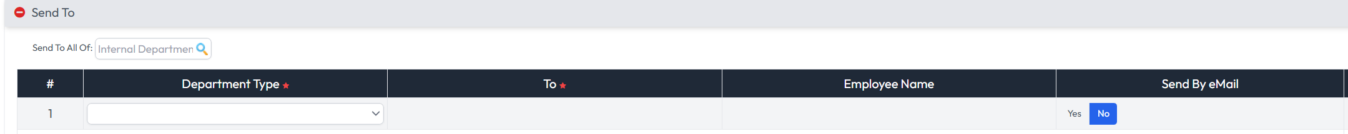
Figure 6: Send To section
- Select the Department Type (required).
- In To (required), select the department or directorate that should receive the letter.
- Leave Employee Name empty to send the letter to the whole department. If you select an employee, only that employee will receive it.
- Choose Yes under Send By eMail if the recipient should also receive it by email.
Tip: Use the Delete (✖) button to remove a recipient row added by mistake.

7 | STEP 7 Attach files and set other options  Screenshot markers: lower part of the form

In the Attachments section, click Add File and select the file to attach to the letter.
Figure 7: Attachments – Add File
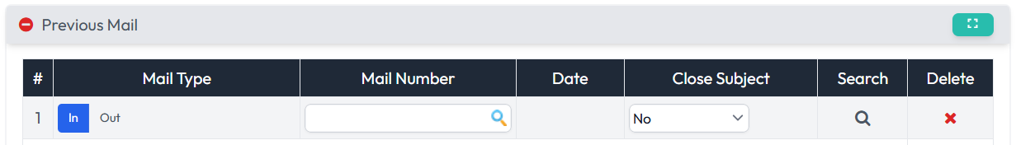
Figure 8: Previous Mail
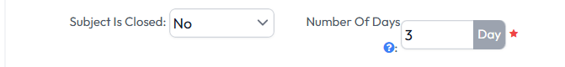
Figure 9: Subject Is Closed and Number Of Days
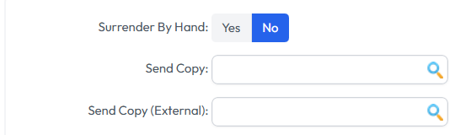
Figure 10: Surrender By Hand and Send Copy options
The remaining fields depend on the letter. Fill in only what you need, for example Send Copy to send a copy to another recipient, or Previous Mail to link the letter to an earlier one. Number Of Days is required and is set to 3 by default.

8 | STEP 8 Send the letter  Screenshot markers: Add button

Check the letter, then click Add at the bottom of the form.
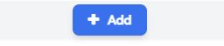
Figure 11: Add button
The system archives the letter in your Department Mail List and sends it to the selected department.
Important: Check the recipients and attachments before clicking Add. Once added, the letter is sent and numbered in your department's mail list.

4. Quick Reference Checklist
✓ | Step | Action
☐ | 1 | Documents Management System › Divan
☐ | 2 | Sub Divan › Department Mail List
☐ | 3 | Department field › press Space › select your department
☐ | 4 | Click + to create a new letter
☐ | 5 | Priority, Mail Class and Subject
☐ | 6 | Send To: Department Type, To (Employee Name only for one person)
☐ | 7 | Attachments › Add File; fill other options as needed
☐ | 8 | Check the letter › click Add

5. Common Issues and Solutions
Issue | What to check
The department list does not appear | Click in the Department field and press the Space key on your keyboard.
The Mail Class I need is not in the list | Contact the IT department, or create it under Divan › Setting › Settings.
Only one person received the letter | An Employee Name was selected in Send To. Leave it empty to send to the whole department.
The letter will not save | Fill in every field marked with a red star: Priority, Mail Class, Subject, Department Type, To and Number Of Days.
I cannot find a letter I sent | Open Department Mail List for your department and use the filter boxes (e.g., Subject or Mail Date).

